Game Design Document

Game Overview

High Concept (Elevator Pitch)

[A one or two sentence description of the game that captures the feel of the game. You want this to be accurate and exciting because it is what you would use to pitch the game to potential funders of the game as well as Steam or other vendor’s descriptions.]
You wake up to find yourself in a Russian facility that is 5000 feet underground. The only way up in through an elevator that leads to a different floor with varying challenges.

Game Summary
[Summarize the game you are going to be creating here. It gives context for the sections that will be coming up.]
You will come across items such as a mallet that will help you break into multiple rooms that have different items. All of these will come together as you explore each floor. You may need to do some backtracking to get through rooms or you may not have to. A text based adventure.

Gameplay

First Minutes
[This section should detail what the player will see in the first couple of minutes when they launch the game and begin to play. Since this game is so small, think of this as more of a brief description of the first few seconds of gameplay. What do you want the player to immediately notice and feel?]
We want them to feel alone and scared. They wake up in this unknown area while tied down to a chair. They must use their wits to escape each room and find a way out of this Russian facility.

Game Flow
[Use this section to describe exactly how you envision the game to be played and what order things will happen in. If you are feeling especially fancy you could even include a flowchart to help describe how the different parts of the game lead the player from one area or screen to the next, or a map.]
Grab different items in each room which then help you progress to different rooms. This will all lead to an elevator that will take you up to the next floor for additional challenges. There are 5 total floors with 2ish rooms in each and they provide varying challenges.

Victory/Lose Conditions
[This section should be where you describe all the different scenarios that could end a segment of gameplay. For instance, if the game were about a brawl between players in a battle-royale game I might say the victory condition is when the players left in the game are all on the same team then that team wins.]
You win by getting to the top floor and exiting the facility. There is also a secret ending that will win the game on the first floor. If responses exceed a certain amount of tries, some situations may fail the player and ask them to restart.

Target Audience
[Describe the target audience of your game. Be specific about the demographics that the game should appeal to as well as the target ESRB rating. Note that for this project the game must not exceed a rating of E10+]
This appeals to all people E10+. It has mild violence that includes knocking people out but other than that it’s for everyone. We want this to reach as many people as possible and thankfully since it’s a text adventure, it’s up to the imagination how graphic you want it to be.

Game Map
Floor 5
Player starts here and must use a scalpel and a mallet to get out
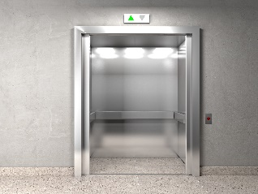

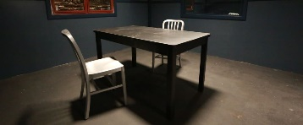
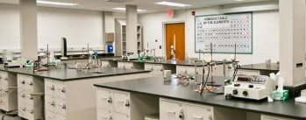



Chemical Lab
Interrogation Room
Elevator/Hallway
Player is then directed to chem lab and must find some acid and a lab coat that is used to deceive guards
You enter the hallway and there will be a guard there, knock him out with the mallet and steal his keycard. Player is always lead to the elevator to progress to the next level
Player starts here and must move a brick in order to find a secret vent
Concrete Room
Elevator
Player is always lead to the elevator to progress to the next level
Bathroom
Player is then funneled into the bathroom through the vent and must use the brick they found to knock out the guard
Floor 4
Player then must use their problem solving skills in order to obtain the keycard the bear has in its mouth
Zoo

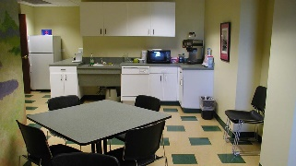
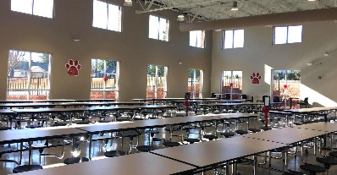
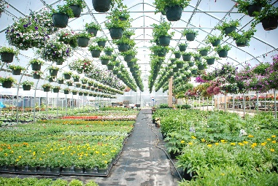
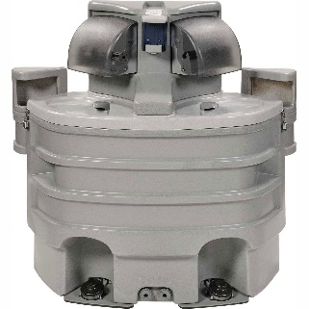
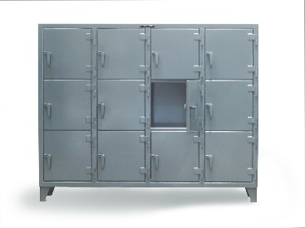
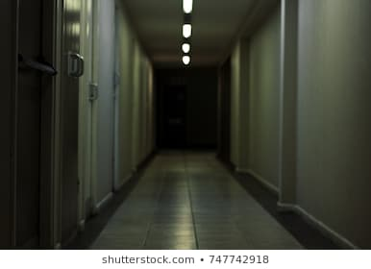
Floor 3
Break Room
Player starts here and must move a brick in order to find a secret vent
Cafeteria
Player is then directed to the cafeteria where they must use a banana and deceive the guards into opening the elevator door

Player is always lead to the elevator to progress to the next level
Elevator
Floor 2

In this room the player is required to explore the green house where they are poisoned by a plant and forced to wash themselves before dying



Inside the hallway, the player finds a locker after washing themselves of the poison and it holds the keycard for the final elevator
You have 4 turns to find the washing station where you need to clean the poison off of you

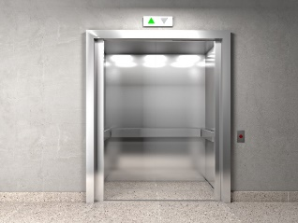
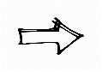

Floor 1

Throne Room


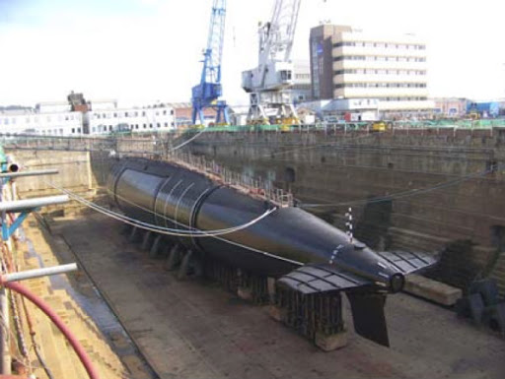

The player starts here and this is the final boss battle of the encounter. They must find a way to defeat bears
The final room is the loading dock where the player is lead outside into the loading dock and they can choose to “release the subs”
Loading Dock

